**MISSION & VISION**

**Road Safety Omni Foundation** envisage to see Safer Road in terms of fewer road traffic crashes, accidental injuries and death, safe and cleaner environment.

Together we integrated Road Safety activities by partnering with public sector, private sector and society in order to propel the Government Strategy for prevention of Road fatalities.

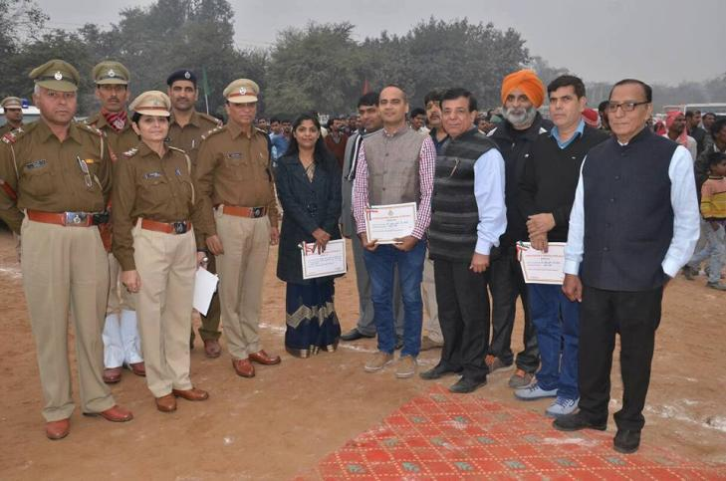 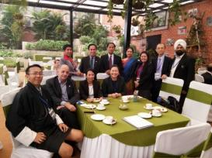

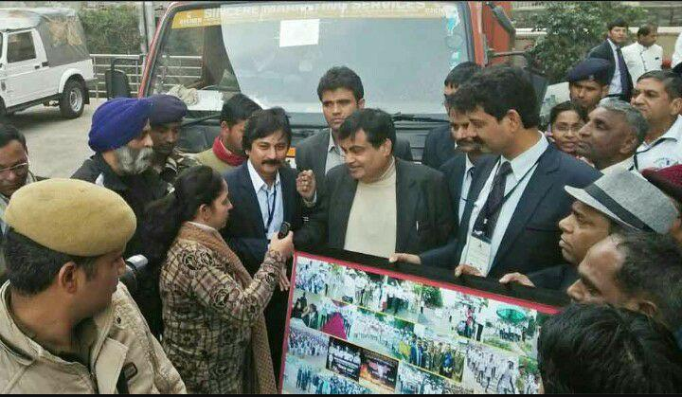 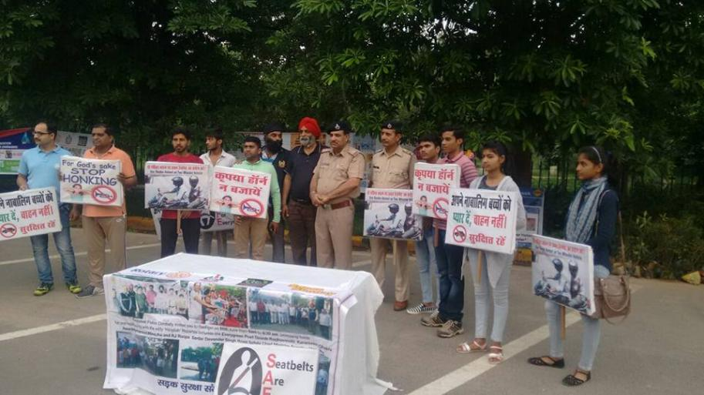

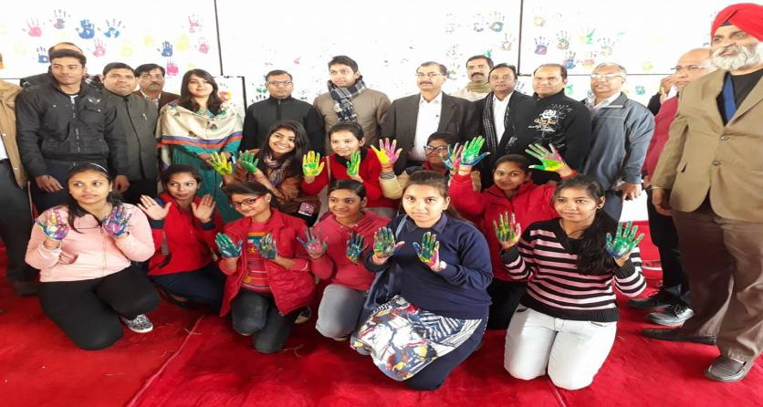 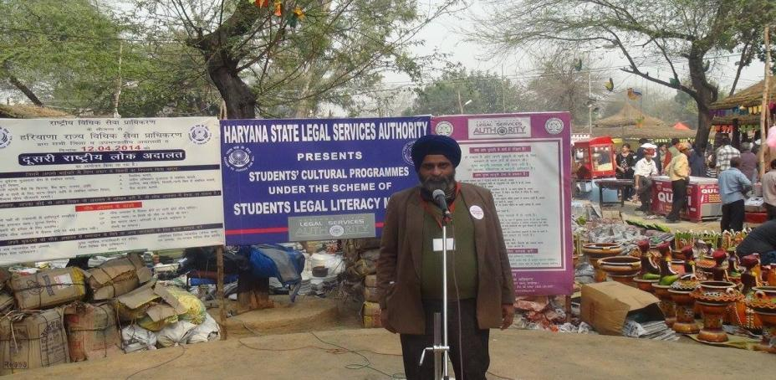

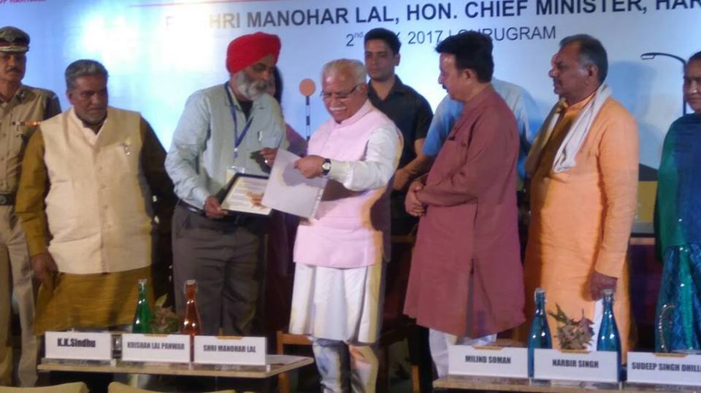 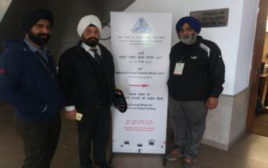

**PROJECTS & EVENTS**

1. Rahagiri
2. Reflector Tape Mission
3. Murari Babu Ram Katha
4. FICCI Seminar
5. Bharat Vikas Parishar